# Arduino while loop

The while loop() is the conditional loop that continues to execute the code inside the parentheses until the specified condition becomes false.

The while loop will never exit until the tested condition is changed or made to stop. The common use of a while loop in [Arduino](https://www.javatpoint.com/arduino) includes **sensor testing, calibration (calibrating the input of sensor), variable increment, etc.**

The syntax is:

1. **while** (condition)
2. {
3. // code or set of statements
4. }

Where,

**condition**: It specifies the boolean expression, which determines the condition to be true or false.

For example,

1. variable = 0;
2. **while** (variable < 100) {
3. // performs the specified task 100 times repeatedly
4. variable++ ; // increments after every execution
5. }

The above code inside the curly braces in while loop will execute continuously and repeatedly as long as the variable is less than 100.

### Flowchart

The flowchart is shown below:

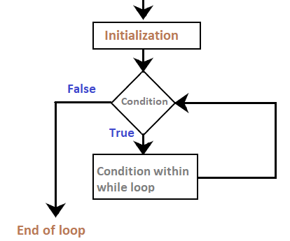

### Code Example

In order to change the flow of the program, we need to change the specified condition inside the parentheses of while loop. The process is much like the if statement.

Let's understand the concept of while loop with two examples.

**Example 1:**

Consider the below code:

1. **int** a = 0;
2. **void** setup()
3. {
4. Serial.begin(9600);
5. **while**( a < 5)
6. {
7. Serial.println("Welcome to Arduino");
8. a = a + 1;
9. }
10. }
11. **void** loop()
12. {
13. }

**Output:**

The message inside the loop will be printed five times, as shown below:

